Biomolecules

________________ is often called the building block of life.  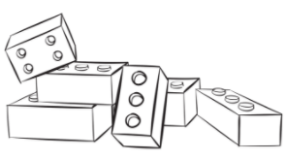 |  | Carbon is the most important atom found in ______________ __________________.  It can join to _____________other atoms at the same time.  It can also form ____________and__________, meaning it can make many ___________________molecules.  These carbon-based molecules are called _________________molecules. They are found in ________ _______________ _______________.
Due to its special bonding properties, carbon can form large molecules called __________________.  Macro= large  Mono- one, singular  Poly- many, multiples | Macromolecules are made up of smaller subunits called ____________________.  When monomers link together, they form______________________.  A polymer is a macromolecule made up of many monomers.  You can think of monomers and polymers like links in a chain or a watch band. If the chain below was a molecule, circle the polymer and box 2 monomers.  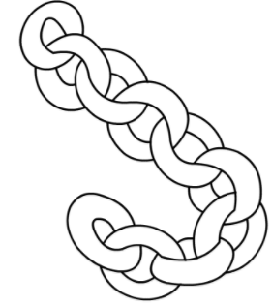
Four Major Macromolecules
1.___________________ | 2.________________ |  | 3.____________________ | 4.____________________

CARBOHYDRATES
Carbohydrates are the main source  of _____________ ______________. They are our ___________ ______________of fuel. | They are made of monomers called ________________, simple sugars, like __________________. |  | Carbohydrate molecules made of only one sugar molecule are called __________________________________.  Example:________________, used for _________  Ribose and Deoxyribose, used to _____________our ____________ _____________.
The suffix –ose usually indicates a type of sugar.  Example: glucose, fructose, ribose  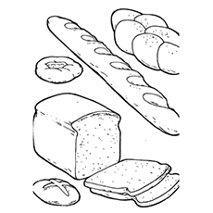  Carbohydrates found in our diet  - _____________  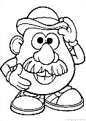  - _____________  - Whole grains  - ______________ (potatoes, corn..) |  |  | Monosaccharides can be joined together to make___________________________, carbohydrates made of ____________sugar molecules.  Examples of important polysaccharides:  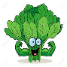  - _____________- how _________store glucose  - ______________- keeps plant ___________strong  - _______________- how ____________  cells store glucose
PROTEINS

Proteins are built from ___________ __________monomers (subunits)  Amino acids link together  like beads on a necklace  to form_______________.  This is why proteins are sometimes called  polypeptides  The _______________(order of) amino acids in the protein chain determines what _________________will be made.  The ___________of the amino acids is determined by ___________in the_________________. |  | There are ________different amino acids used by cells to make proteins. The amino acids are put together using peptide bonds.  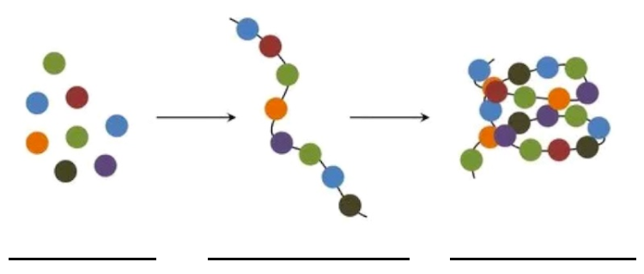  Your ____________can make _________of  these amino acids; the others come from _______________that you eat.  If we think of proteins like these necklaces, how could you change them to make them different?  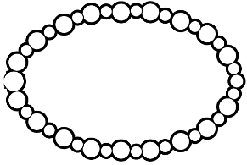  Hint: It has the same effect on proteins with amino acids
Proteins have many different jobs like…  Make up______________, ligaments, tendons, hair and skin  Act as ___________________ to speed up chemical reactions  Also act as _______________like insulin; _______________  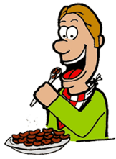  controls blood sugar levels.  Proteins in _________ ___________________help _____________molecules in & out of cells |  |  |  | 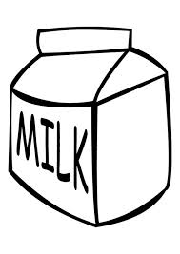  Food sources for protein include___________, ____________, ___________________, and ______________products like milk and cheese.  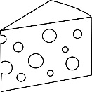

LIPIDS

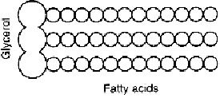
Lipids are composed of monomers called _____________ ___________.
A typical lipid has _____ fatty acids tails bonded to a molecule
called a___________________.

Lipids are _______________; this  means they do _______have opposite charges.  Water is_____________; it does have opposite  _______________, like a magnet.  A __________________________is a lipid that joins with proteins to make ________ ________________________(cell membranes wrap around the outside of the cell kind of like skin)  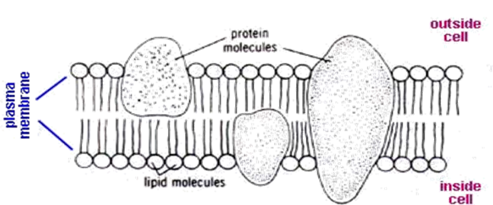  A phospholipid is still non-polar, but it is also has a _____________________section and a ______________________section.  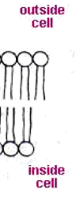  Label:  Hydrophilic section  Hydrophobic section  Glycerol  Fatty acids  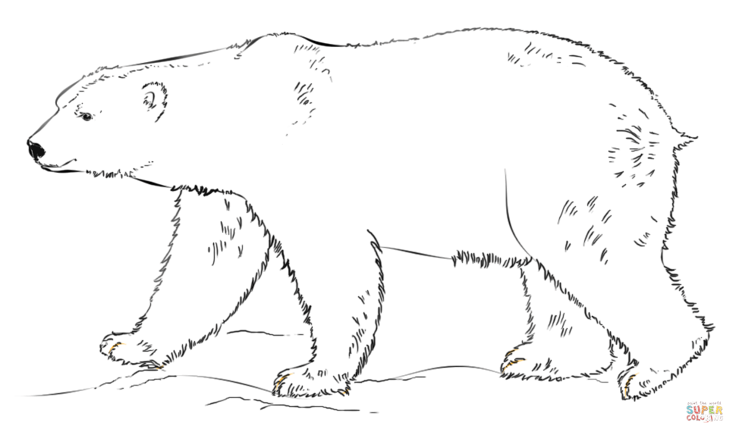  Lipids can be used to store energy __________ _______________.  Lipids help maintain  ____________________ (balance), act as _________________ (testosterone and estrogen), and can provide _______________________(fruit, ears and bees!)  Lipids are found in __________ and __________.  They store huge amounts of ________________  ________________in organisms. | 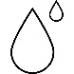  Side note: Water  Water is made of ____  Hydrogens atoms  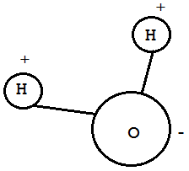  and ____Oxygen atom;  these are held  together by _________  ____________bonds.  Water molecules bond  to other water  molecules because the  ______________charged  part of one is attracted to  the ________________part of another,  like magnets; these are called ______________bonds and are ________strong.  In the image below, circle all of the covalent bonds and box all of the ionic bonds.  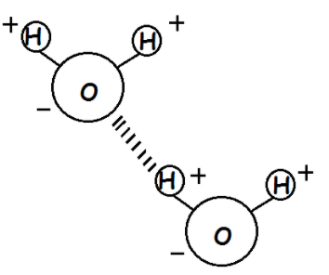  Hydro- means water  -philic means loves, likes  -phobic means hates, afraid of  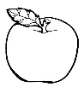  Why would fruits needs lipids for waterproofing?  ___________________________________________  ___________________________________________  ___________________________________________  ___________________________________________  ___________________________________________  ___________________________________________  ___________________________________________  ___________________________________________  ___________________________________________  ___________________________________________

NUCLEIC ACIDS

Nucleic acids are made from monomers called ______________________. | 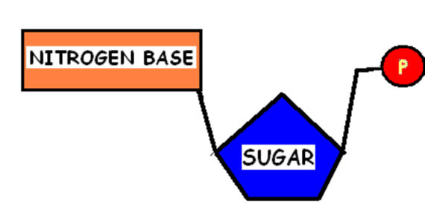  Each nucleotide has ______ parts  - ___________________base  - ________________  - ________________________
There are ___________ types of nucleic acids. | - ___________- stores _________________information  - ___________- carries ________________________from DNA to the cell so proteins can be made  - ___________- used by cells to ____________and _________________________________________
The structure of ATP:  Be careful! It looks a lot like a regular nucleotide, but ATP has 3 phosphates attached, not just one. | 