CELL CYCLE: HOW CELLS MAKE MORE CELLS
The cell cycle is the regular pattern of growth, DNA duplication, and cell division that occurs in ___________________ cells  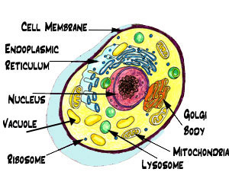 |  |  |  |  |  |  |  |  |  |  |  |  |  | Cell Cycle Main Idea:  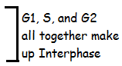  The cell cycle has 4 main stages and the an end action  #1. Gap 1 (G1)  #2 Synthesis (S)  #3 Gap 2 (G2)  #4 Mitosis (M)  END Cytokinesis
INTERPHASE: Gap 1, Synthesis and Gap 2 together make up______________.

During interphase, when a cell is not dividing, the DNA is loose and stringy. It is called ___________ | G1 |  |  |  |  |  |  |  |  | S |  |  |  |  |  |  |  |  | G2
 | During Gap1, the cell carries out its normal activities, grows and makes ___________________. |  |  |  |  |  |  |  |  | During the Synthesis phase, the cell makes a ______  ______________. |  |  |  |  |  |  |  |  | In the Gap 2 phase, the cells continue normal function, undergo additional growth, double checks for damage to DNA and prepare to divide.
 | MITOSIS: Mitosis is the division of the cell ____________and its contents
1. ______________ |  |  |  |  | 2. _______________ |  |  |  |  |  |  | 3.________________ |  |  |  |  |  |  |  |  | 4. __________________
 | CYTOKINESIS
After division of the nucleus, the cell undergoes_________________.

Cytokinesis is the division of the cell _______________, resulting in two daughter cells that are genetically _______________to the original cell.

INTERPHASE |  |  |  | MITOSIS |  |  |  |  |  |  |  |  |  |  | CYTOKINESIS
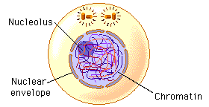 |  |  |  |  |  |  |  |  |  |  |  |  |  |  | 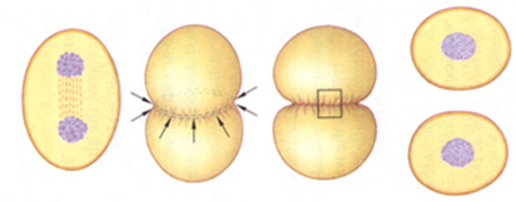
Cell Cycle Main Idea: Cells divide at different rates

Prokaryotes generally divide much faster than  ____________________. |  |  |  |  |  | The rate at which your cells divide depends upon your body’s ________for those cells. |  |  |  |  |  |  |  |  | The rate of cell division in embryos and children is __________than that of adults. |  |  |  |  |  |  |  | The rate of cell division in an adult varies within the different ___________.
Cell Cycle Main Idea: Cell Size is Limited

If cells were too small, they could not contain all the needed _________________and molecules. |  |  |  |  |  |  | If cells were too big, materials could not be _______________in and out of the cell membrane efficiently. |  |  |  |  |  |  |  |  |  |  |  |  |  | When cells increase in size, their ____________ increases faster than their _________area.
BACK TO MITOSIS…

Mitosis Main Idea: Chromosomes condense at the start of mitosis

A chromosome is a long strand of ______that consists of a number of__________.  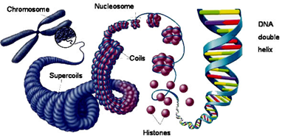  You have ___ ____________ in each of your body cells. |  |  | Before the cell undergoes mitosis, the chromatin “condenses” or becomes tightly ____________  around certain protein molecules called ___________.  (Circle the histones) |  |  |  | 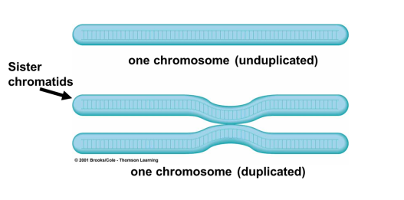 |  | After the chromatin ___________, they form chromosomes.  Remember, the chromosome was ________during the S phase of the cell cycle.  The chromosome now has an “X” shape with each side consisting of ________________. |  |  |  |  |  |  |  |  |  |  | One half of a duplicated chromosome is called a _____________  The two identical chromatids are called _____________chromatids.  Sister chromatids are held together at the  ____________
Mitosis Main Idea: Mitosis and cytokinesis produce two genetically identical daughter cells.

Mitosis is the division of the cell ______________and its contents. |  |  |  |  |  |  |  |  | Purposes: To produce two new _______________ ________with the exact same kind and number of chromosomes as the _______________(parent) cell. |  |  |  |  |  |  |  |  |  |  |  | During_______________, because the DNA is still loose chromatin, the chromosomes are not____________.
Main Idea: Mitosis and cytokinesis produce two genetically identical daughter cells.
REMEMBER: PMAT

What’s going on? What does it look like?

PROPHASE
The chromatin condenses into tightly coiled ______________________.  The nuclear membrane (envelope) breaks down.  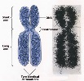  Centrioles move to opposite ___________of the cell. Spindle ________form.  The chromosome was copied during_____________, and now looks like an “X”. | 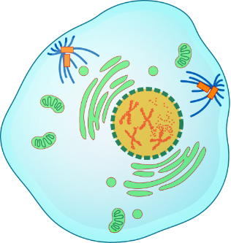
METAPHASE
Chromosomes line up along the cell’s _________________.  Spindle fibers attach to each __________________ | 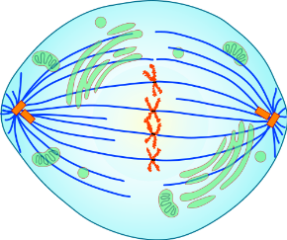
ANAPHASE
What’s going on:  ____________ _______________ _________________to opposite sides of the cell. | 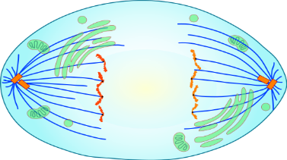
TELOPHASE
A complete set of _______________chromosomes are positioned at each pole of the cell.  Nuclear membranes form.  Chromosomes _____________back into chromatin.  Spindle _____________fall apart. | 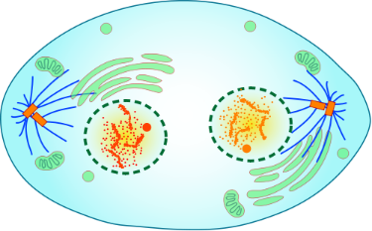
CYTOKINESIS
Following mitosis, __________________pinches the cell membrane (in animal cells) and divides the cytoplasm into two ________________ ____________.  Each new cell has a genetically __________________ nucleus.  During cytokinesis in plant cells, a _________forms between the two nuclei which becomes a new ______________________________. | 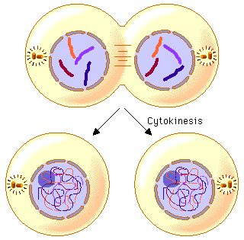  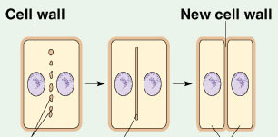
What Happens When the Cell Cycle Goes Wrong…?
Main Idea: Cell division is uncontrolled in cancer

___________is a class of diseases caused by ____________  cell division.  Cancer cells form disorganized  clumps called _________. |  | 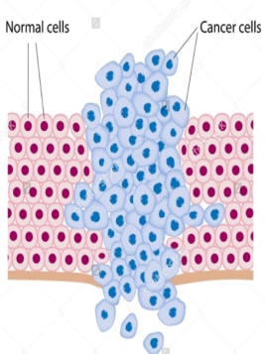  A tumor is _________if the cancer cells remain clustered together.  They are usually _____________ and can be removed.  A tumor is  _____________  if the cancer cells spread to other parts of the body. |  |  |  |  | Some of these mutations can be caused by exposure to environmental agents called  ______________.  Carcinogens are substances that ___________  or ____________  cancer |  | _____ ____________: smog, industrial smoke, car fumes  Can cause- lung cancer, nose cancer, leukemia  ____________:  Human Papillomavirus (HPV)  Hepatitis, HIV  Can Cause:  Organ failure, some cancers, decreased immune system | _______  ________________:  Nuclear reactor meltdowns, sun and tanning bed exposure, X-rays  Can cause- genetic mutations, skin cancer, thyroid cancer, leukemia
Types of Reproduction

Reproduction is a process that makes new _____________from one or more ____________organisms.
It happens in two ways: sexually & asexually

Sexual  Sexual reproduction involves the joining of two cells called _______________(eggs and sperm cells), one from each of two parents.  There are Advantages and Disadvantages to both types of reproduction  Advantages Disadvantages |  |  |  |  |  |  | Asexual  Asexual reproduction is the production of offspring from a __________parent and does not involve the joining of_____________.  The offspring are ______________ _____________ to each other and the parent.
Sexual  Lots of _________  ___________  Able to live in a __________ of environments  Can _______ to changes in conditions | Asexual  Does not require __________  ______ or much energy.  Produces many offspring quickly.  In a favorable environment, creates thriving populations |  | Sexual  Needs more ______ and _________ (finding a mate, taking care of offspring)  Produces _________  populations |  | Asexual  Population is ____________________, so there is a limited ability to adapt.  Population may face massive die-off if __________ changes. |  | 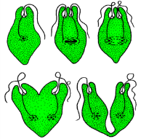  Asexual reproduction is the primary form of reproduction for single-celled organisms such as_______________, and  _______________.  Many_________, some animals and  fungi can reproduce _____________as  well.
 |  |  |  |  |  |  | _______________________is the asexual reproduction of a single-celled organism by division |  | Like mitosis, binary fission results in two daughter cells that are _____________  ____________to the parent cell. | 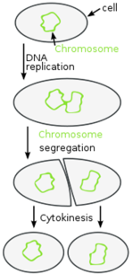
Specific Types of Cells
Main Idea: Specialized cells perform specific functions

To form the _____________ ________________that make up your body and the body of other complex organisms, cells must ________________. |  |  | The process by which unspecialized cells develop into their special forms and functions is called _______ __________________. |  |  | Almost every cell in your body has a full set of________. |  |  | Each type of cell uses only the DNA needed to carry out its ____________
 | Stem cells are a __________type of body cells that have the ability to
Divide and ____________ themselves for a long period of time  Remain _______________  Develop into almost ______ _________of specialized cell |  |  |  |  |  |  | Stem cells are used to ________ patients with leukemia and lymphoma (forms of cancer)  Stem cells may cure other diseases or replace ____________ ___________ and organs
 | Main Idea: Human cells are divided into two types.
Somatic Cells |  |  |  |  | Gametes
Somatic cells, or _________ __________, make up body tissues and organs.  DNA in somatic cells is _______ ____________on to offspring |  |  |  |  | Gametes are ________cells  DNA in the sex cells _______ ______passed to offspring.  Males produce ___________and females  produce___________.
Body cells are____________, meaning each body cell has ______ _________of each chromosome: one copy from the mother and one from the father.  ____________cells are represented by (______)  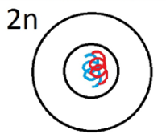  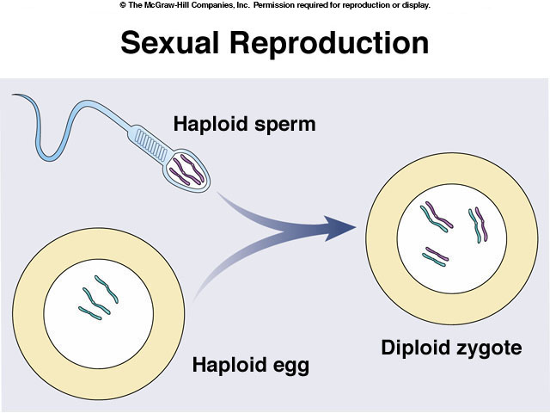 |  |  |  |  | Gametes are _____________cells, meaning that they only have_________ _________of each chromosome.  Haploid cells are represented by (_____)  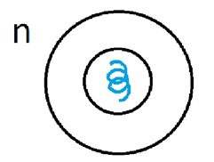

 | Main Idea: Each species of organism has a characteristic number of chromosomes in each body cell.
The normal number of chromosomes in human body cells is ____ total or ____ homologous pairs. |  |  |  | Homologous pairs are like pairs of socks-two of the same thing. | 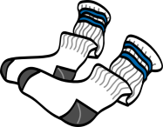 |  | Homologous chromosomes are pairs of chromosomes, one inherited from the  _____________, one from the____________, that have the same length and appearance.
Homologous chromosomes have copies of the same  _________, although the two copies may differ and are called alleles.  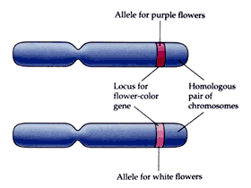 |  |  |  |  | 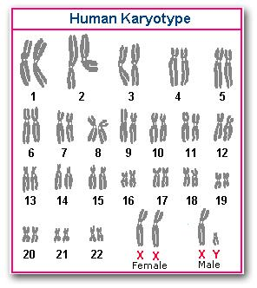  A karyotype looks at all of the homologous chromosome pairs in order.  Does the below karyotype belong to a male or female?  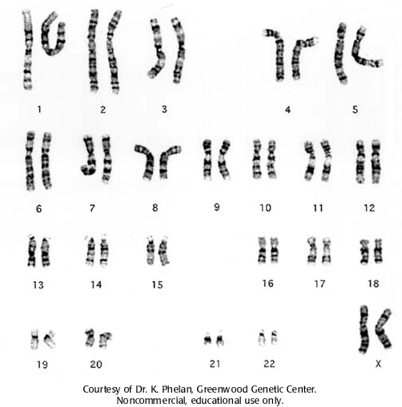
Each pair of human __________________________
have been assigned a number-from biggest to
smallest. (1-23)

Human chromosome pairs 1 through 22 are called
_________________.

Autosomes are chromosomes that contain genes for characteristics ____ related to the _____of an organism.

The 23rd chromosome pair in humans is _____ chromosomes.

In mammals, including humans, an organism with two ____chromosomes is a ____________.  The larger X chromosome contains______________  ________, many unrelated to sexual characteristics |  |  | An organism with ____ and ____chromosome is a male.  The Y chromosome directs the development of ________________  characteristics and carries few genes.
Main Idea: Gametes are formed by a process called_____________.

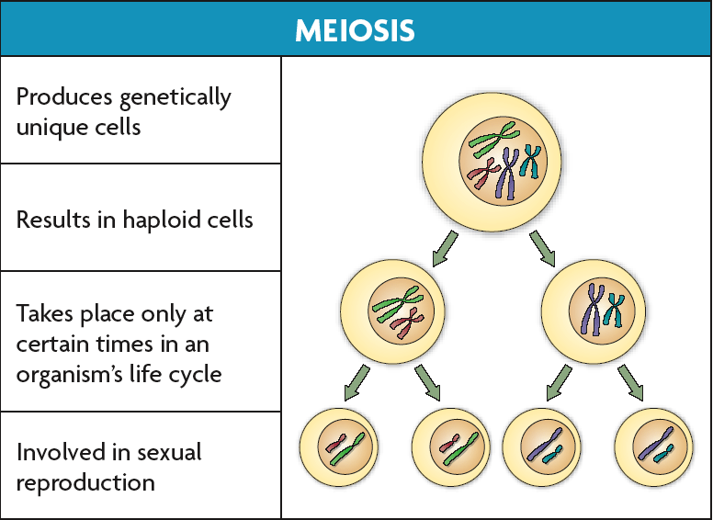

Meiosis ___________the number of chromosomes in the
gamete to _________ the number of chromosomes in
the parents body cells.
Diploid (2n) → haploid (n)

During meiosis, diploid cells undergo ________cell
divisions that result in haploid cells.

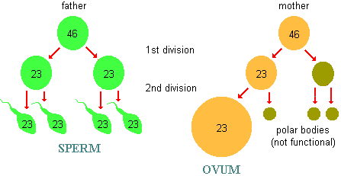

Cells go through _________________of division in meiosis: meiosis I and meiosis II

Meiosis creates _____________________________.

Some REALLY IMPORTANT things happen during Prophase I
- The homologous chromosomes line up to form a _________.
Tetra= 4
- The inner most chromosomes then _________________.
By crossing over, the cells have a higher genetic diversity!
In the picture below, the letters represent ___________(different versions of the same gene). The inner most chromatids__________. When they separate, they have ________________some their alleles.
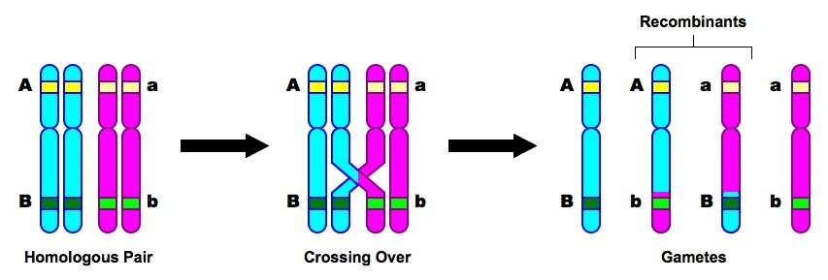
Points to notice: The gametes with chromosomes that have crossed over are called recombinants because they were “recombined” to become whole chromosomes.
Even though the chromosomes are crossing over, they all still end up with a full set of genes (the starting homolougous pair have an A and B and all of the ending products have and A and B-some are uppercse and some are lowercase, but they all have an A or B

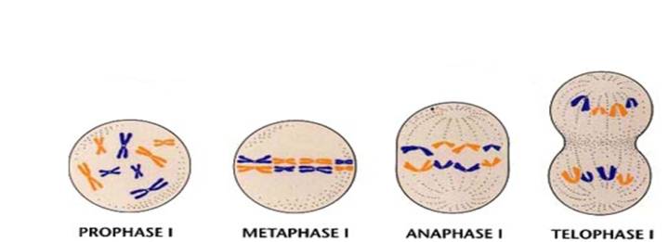
Main Idea: Meiosis is very similar to Mitosis
During meiosis I, ________________________
_______________________pair up along the cell equator and are divided into separate cells.

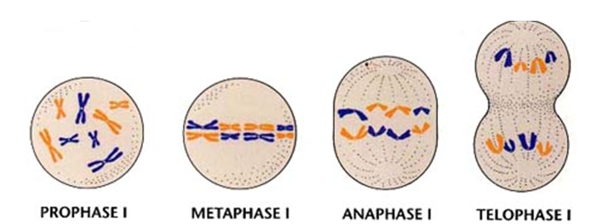
In meiosis II, sister chromatids are divided into separate cells making a total of four ______________unique _____________cells.

Notice how we went from a diploid cell with homologous chromosomes to haploid cells with only single sets of chromosomes.
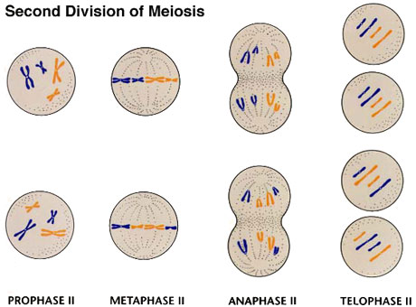

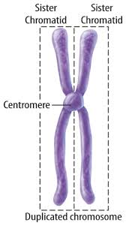
Sister chromatids
are duplicated
chromosomes that
remain attached
to each other.
