Cell Energy, Photosynthesis, and Cellular Respiration
INTRODUCTION
Energy for most living things comes from ________. That energy comes from the sun. |  | Organisms that use __________ __________ from the sun to produce food are ______________________.  Example: _____________ and ______________ |  |  | Organism that cannot make their own food are called ________________.  Example: _________________ and most microorganisms
ENERGY

A special kind of molecule used by cells to store and transport energy is called _________. | __________=  _______________  _______________ |  | ATP transfers energy from the ____________ of food molecules to cell processes. | The parts of an ATP molecule:
All energy is stored in the ____________ of molecules—breaking the bond releases the energy.  When the cell has energy available it can store this energy by adding a _______________group to a molecule called ADP, or ______________ _______________________.  When the cell needs energy, the ______ phosphate bond is broken. A burst of energy is _____________, and ATP ______________back to ADP. |  |  | 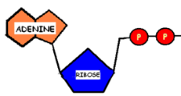+ _________= 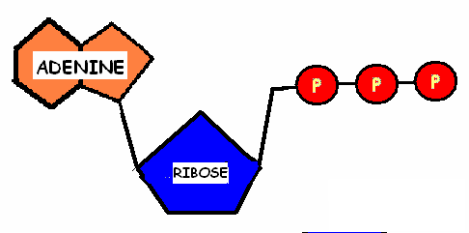 Energy is stored.  ________ __________  Circle the part of the molecule in both diagrams where the energy is stored or released from within the molecule.  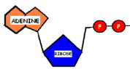  - ____= ____________ + Energy is released.
Energy is replaced when the phosphate is added back to ADP to make it ATP again. |  |  |  | The energy to do this comes from molecules in foods,  like __________________.

PHOTOSYNTHESIS
Technical Definition:  Photosynthesis is the process by which the energy of ___________is ____________into the energy of _____________or sugar. |  | Photosynthesis occurs in the __________________of plants (That’s an organelle!!)  Plants gather the sun’s energy with light absorbing molecules called ___________.  The pigment that ___________light for photosynthesis is called ________________. |  | 1961- American chemist ________________________  received the Nobel prize for  figuring out the  chemical _______________  used by plants to make sugar
General formula for photosynthesis: |  | carbon dioxide + water + light glucose + oxygen CIRCLE the reactants  OR and BOX the products  in both expressions  6CO₂ + 6H₂O + light C₆H₁₂O₆ + 6O₂
Photosynthesis has 2 Parts
LIGHT DEPENDENT REACTIONS  (__________light  1. Energy from _____________is absorbed by chlorophyll.  2. H2O is broken down and _____________is released  3. Energy in the form of ______is made | The light dependent and the  light independent  are BOTH necessary  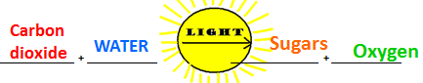  for photosynthesis to work |  |  |  | LIGHT INDEPENDENT REACTIONS  (________ _______ ____________light)  1. Carbon dioxide CO2 ______from the atmosphere is taken in by the plant  2. The energy made in the light- _______________ reactions is used to make __________or sugar from the carbon in the CO2.  The light independent reaction is also called the ____________________
The Big Picture
PHOTOSYNTHESIS provides the _____________ we breathe and the __________
heterotrophs (like us) consume to survive.
Vocab: Photo= light Synthesis= to make
Dependent= needs/relies on Independent= does not need/ does not rely on
Now we know that autotrophs, like green plants, use photosynthesis to trap energy from sunlight to make food/sugar for energy.
So what’s next? How do the plants use the food they just created?
CELLULAR RESPIRATION
Technical Definition:  Cellular respiration is the process by which the energy of _____________is ______________in the cell to be used for life processes (movement, breathing, blood circulation, etc…) |  | Cells require a constant source of __________ for life processes but keep only a _________ ____________of ______on hand. Cells can regenerate ATP as needed by using the energy stored in _________like glucose. |  |  | The energy stored in glucose by photosynthesis is _____________by cellular respiration and repackaged into the energy of ATP.  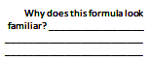
General formula for Cellular Respiration: | 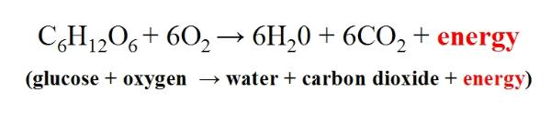
The _____________in photosynthesis are the same as the _____________of cellular respiration.
There are 2 types of Cellular Respiration: |  |  |  | Cellular respiration  takes place in  _______ cells.
AEROBIC  (With Oxygen) |  | ANAEROBIC  (Without Oxygen)
Aerobic cellular respiration requires oxygen.  Occurs in the _________________ of the cell.  Total of ____________molecules produced. |  |  | Occurs when ____ ________________is available to the cell (2 kinds: Alcoholic and Lactic Acid)  Also called ______________________________  Much ___________________produced than in aerobic respiration.
 |  |  | _____________ fermentation—occurs in _____________and ________  Process used in the ____________and _____________ industry—yeast produces CO₂ ____during fermentation to make dough ___________and give bread its holes.  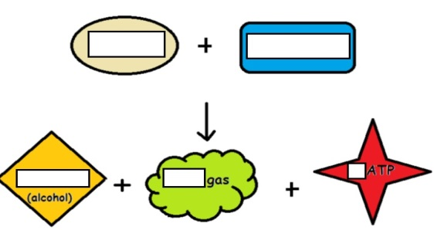  Yeast + glucose = ethanol + CO2 gas + 2 ATP |  |  | _________________  fermentation—occurs in ____________________  Lactic acid is produced in the muscles during rapid _____________when the body __________supply enough _____________to the______________—causes burning sensation in muscles
Vocab: Aero=oxygen/air
A/An= Without

