THE CELL MEMBRANE: So Important it Gets its Own Section in the Notes
The cell membrane is a ________ _____________ that surrounds eukaryotic and prokaryotic cells.  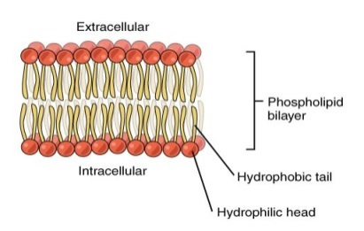 | Job  Description: | 1. It forms a ______________ between a cell and the outside environment  2. It controls the ____________ of materials ______ and _________ a cell. |  | Characteristics: |  | The cell membrane is made up of a ___________ _________ of molecules called ________________ mixed in with a variety of other molecules. |  | The cell membrane is fluid and __________.  The ________________ molecules can move around in a fluid-like manner.
 | The Parts of the Cell Membrane
Phospholipids are composed of 3 basic parts:  1. a charged ____________ head  2. a ____________ molecule  3. two _________________ chains/tails | The ________heads of the phospholipids are attracted to  the polar water molecules __________and _________  of the cell. |  |  |  | The Cell Membrane isn’t only made  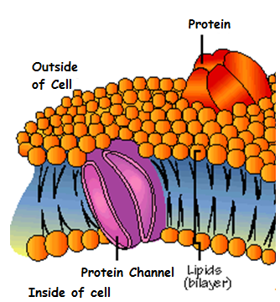  of phospholipids though- it has other molecules embedded in the phospholipid bilayer.
 | The phospholipid heads line up and form the ________  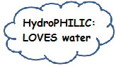  surfaces of the  cell membrane.  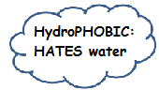  The fatty acid tails are ___________ and cannot form bonds with water. |  |  |  | Protein molecules:  Embedded in the cell membrane and help flow ____ and ____ of the cell.  Cholesterol molecules:  _____________ and keep the cell membrane ________.  Carbohydrates:  Attached to membrane proteins; help cells to ___________ ___________  ___________. |  | 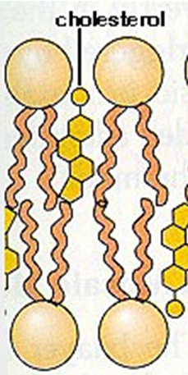  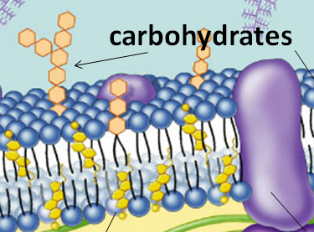
Because the phosphate head has a slight charge,
phospholipids are ________ molecules.

Non-polar tails are attracted to each other and _________ by water.
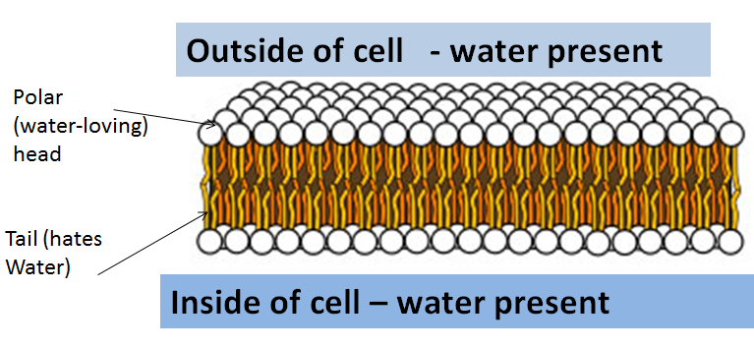
Cell Transport: How the Cell Membrane Moves
Materials Into and Out of the Cell
The cell membranes is  _____________  _____________  This means that it allows  some, but not all  ___________  to pass through it. |  | The cell must be able to control the  in and out movement of  certain molecules and ions  Selective permeability allows the  cell to maintain ____________  in the event that the  environment __________  ____ _____ changes.
Substances Pass Through the Cell Membrane in Different Ways
Some of these methods require the cell to _________ _________ and some do not. | Passive Transport is the  Movement of molecules across the cell membrane _________ _________ input from the cell.  Three types:
Factors that determine how something moves across the membrane:  1. ______ of the molecule  2. ___________ of the molecule  3. ____________ of the molecule inside and outside of the cell. | Diffusion  Is the movement of molecules iin a fluid or gas from a region of _______ concentration to a region of _________ concentration  OR  Difference in concentration in one area compared to another=  _____________________  ___________________  Diffusion moves down the concentration gradient |  | Osmosis  Osmosis is the _____________of _______across a semi-permeable membrane from an area of higher water concentration to an area of lower water concentration.  The higher the concentration of __________in a solution, the lower the concentration of __________in the same solution.  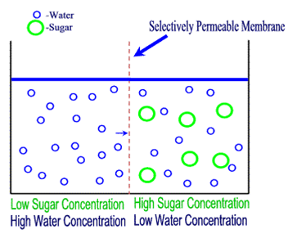  Osmosis/Diffusion continues until the concentration reaches equilibrium. |  | Facilitated Diffusion  The diffusion of molecules across the membrane through transport proteins.  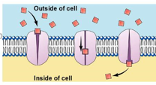  This happens because some molecules cannot easily diffuse across the _______ _________________.
2 kinds of proteins involved in facilitated diffusion:
__________ and __________
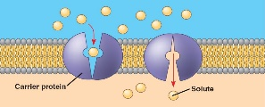
Carrier proteins grab a molecule, change shape, and spin around like a revolving door.

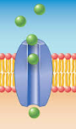
Channel proteins create a __________
through
which
molecules
can pass.
Concentration is the number of molecules of a substance in a given volume.
Circle the glass of water with the highest concentration of salt in it.
Cell Membrane Continued
Some substances cannot get into or out of the cell membrane by ____________  transport. | The cell has three ways to handle these substances.  They are…
 |  | Active Transport  Happens when a cell uses __________ to transport molecules from a region of_______  concentration to __________  concentration.  Performed by thousands of transport protein “________” embedded in the cell’s _______ _____________.  Transfer protein pumps are positioned across the membrane so one part is on the inside of the cell and one part is on the outside.  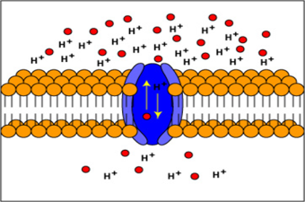  Example: this happens in ___________ (nerve cells). The membrane proteins are constantly pumping ions in and out of the cell so they can send messages to the body from the brain. | Endocytosis  The process of taking in large molecules into the cell by ________________ _______  in a membrane and forming a vesicle.  In order for a cell to transport very large ______________ or a large substance in vesicles, it costs the cell energy.  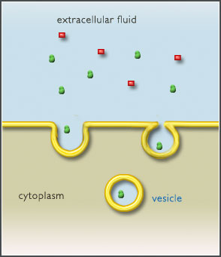  Endocytosis Process:  1. the membrane forms a ___________ around the substance.  2. pocket breaks off and forms a ____________.  3. The vesicle then fuses with a ________________.  4. The lysosome _________ the vesicle and the contents.  Two types  Pinocytosis= “cell drinking”  Phagocytosis= “cell eating” | Exocytosis  The ____________ of substances out of a cell by the ____________ of a vesicle with a membrane.  Exocytosis Process:  1. A _______________forms around materials to be sent out of the cell.  2. The vesicle fuses to the _______ ____________________.  3. The cell membrane opens to the ______________ of the cell and releases its contents.  Vocab Corner  Hydro- water  Phobic- afraid/hate  Philic-loves  Cyt- cell  Phago- eating  Pino- drinking  Exo- outside  Endo- inside  Facilitate- to help
In other words, the cell has to work AGAINST the _______________
_____________; below is what that would look like with a semipermeable membrane.

It COSTS energy (ATP) to go AGAINST the concentrations gradient.

Our cells are bathed in solutions and the __________________  of solutes in and out of the cell can cause the cell to ____________ ____________. | Types of Solutions
Salt is a ____________. | Isotonic  A solution is isotonic if there is the ________ amount of ___________ inside the cell as in the solution. | Hypertonic  A solution is hypertonic if it has a _____________ concentration of solute than the cell does. | Hypotonic  A solution is hypotonic has a ______________ concentration of solute than inside the cell.
SALT SUCKS  When it is concentrated inside or outside of the cell, it will draw the __________ in its direction.  This is why you get thirsty after eating something salty.  Cell _____________  Depends on balancing water uptake and loss.  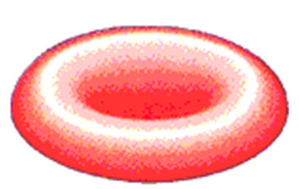  _______________  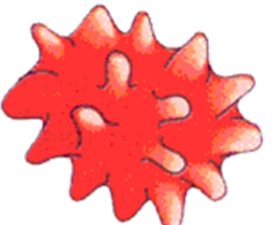  _______________  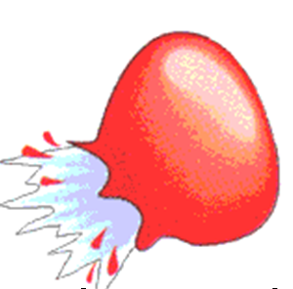  _______________ | If a cell is in an _____________ solution, water molecules will move in and out of a cell at an __________ ___________.  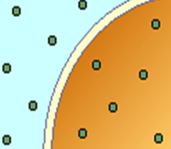 | If a cell is in a _________________ solution, water will flow _______ of the cell, causing it to __________ (shrivel) or die  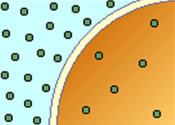 | If a cell is in a _________________ solution, water will diffuse  (osmose) into the cell. If too much water enters the cell, it could ________ (burst).  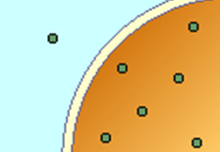
 | The cell’s __________  will not change. | The cell will shrink. | The cell will swell.
 |  | 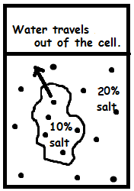 | 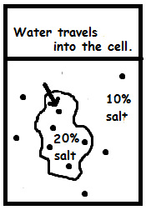
 | In this case, the cell is _________________ to the solution. | In this case, the cell is _________________ to the solution. | In this case, the cell is _________________ to the solution.

