ENZYMES
All enzymes are made of _________________________.
Info and Vocab
_________________________ _______________: the energy needed to START a chemical reaction.
An enzyme is a type of ____________________, which does two things 1) reduces the energy needed for a chemical reaction and 2) increases the rate of the reaction (speeds it up).
The specific reactants the enzyme works on are called _____________________ and binds to it at a place called the _______________ _______________.
An exothermic chemical reaction _________________ energy in the form of heat. An endothermic reaction __________________energy in the form of heat.
- Color the exothermic beaker blue
- Color the endothermic beaker red.
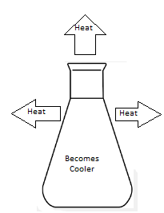
- Color the direction of heat orange for both

This is a _____________________ reaction.

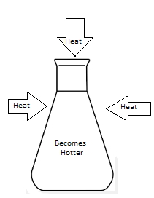

This is a ____________________ reaction.
Chemical Reactions Need Energy and Enzymes Can Help!!
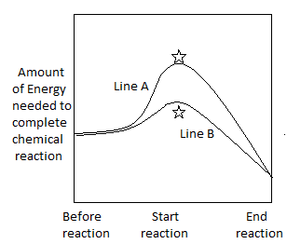
Line A shows the reaction with/ without the help of an enzyme.
Line B shows the reaction with/ without the help of an enzyme.
The points on the graph with the stars mark the ________________________.

Enzymes are Specific
Enzymes are proteins, which means they are specific. This is explained in the Lock and Key Model.
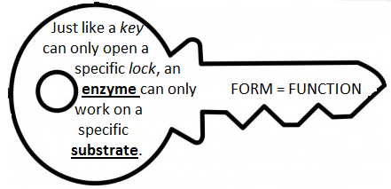

What does the phrase “Form = Function” mean?
___________________________________________________________________________________________________________________________________________________________________________

What happens to a protein when the shape is changed?

We know that when talking about proteins (and enzymes since they are made of proteins) that form = function.
What is the process of changing/destroying the shape of a protein/enzyme called?
__________________________________
What are 2 factors that can cause this?
- ____________________________
- ____________________________

What is a real life example of destroying the shape of a protein?
___________________________________________________________________________________________________________________________________________________________________________

Draw a diagram of what it would look like for an enzyme to go through the above process.

Draw a diagram of an enzyme attaching to a substrate and the products created (should have 3 steps)
Be sure to label: active site, substrate, enzyme, products, reactants

_____________

What did you notice about the enzyme
after the process above?
______________________________
_________________________________
______________________________

