MACROMOLECULES
INTRODUCTION
Many of the molecules in living cells are so large that they are known as macromolecules, which means “giant molecules.” Macromolecules are made from thousands or even hundreds of thousands of smaller molecules. Macromolecules are formed by a process known as polymerization (pah-lih-mur-ih-ZAY-shun), in which large compounds are built by joining smaller ones together. The smaller units, or monomers, join together to form polymers. The monomers in a polymer may be identical, like the links on a metal watch band; or the monomers may be different, like the beads in a multicolored necklace.

CARBOHYDRATES
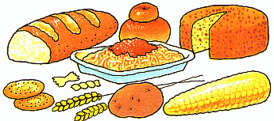
Carbohydrates are compounds made up of carbon, hydrogen, and oxygen atoms. Living things use carbohydrates as their main source of energy. Single sugars are called monosaccharides. Glucose is an example. Disaccharides, like table sugar or sucrose, contain two monosaccharides. Polysaccharides are large molecules containing many monosaccharides bonded together. Starch, glycogen, and collagen are examples of polysaccharides.
Carbohydrate Procedure:
1. Color the monosaccharide (glucose) molecules RED.
2. Cut out the molecules and paste them together in appropriate ways so that you have
a. One monosaccharide (just glucose)
b. One disaccharides (2 simple sugars bonded together)
c. One polysaccharide (many sugars bonded together)
3. Glue them on your answer sheet in the appropriate place and answer the questions.
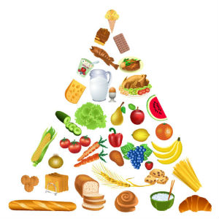
LIPIDS
Lipids are a large and varied group of biological molecules. They are not soluble in water. Lipids can be used to store energy; make up cellular membranes; and as waterproof coverings. A lipid is formed from a glycerol molecule and three fatty acids of different types. Lipids can be saturated or unsaturated. Saturated lipids are solid at room temperature – like butter and wax. Unsaturated lipids are liquid at room temperature – like oils.
Lipid Procedure:
1. Color the glycerols BLUE and color each of the fatty acid molecules a DIFFERENT color.
2. Cut them out and paste them together so that one glycerol connects with three fatty acids to form a lipid. Make two lipids.
3. Glue them on your answer sheet in the appropriate place and answer the questions.
NUCLEIC ACIDS
Nucleic acids are polymers assembled from monomers called nucleotides. Nucleotides consist of three parts: a sugar; a phosphate group; and a nitrogenous base; only some nucleotides fit together, similar to puzzle pieces.
Nucleic acids store and transmit hereditary or genetic information. The most well-known nucleic acid is DNA- DNA stores the “master code” of genetic information.
Nucleic Acid Procedure:
1. Color each nucleotide one color. Each is made of 3 parts: Sugar (S), Phosphate (P) & a Base (A, T, C, or G).
- Color all nucleotides with the base A YELLOW.
- Color all nucleotides with the base T GREEN.
- Color all nucleotides with the base G ORANGE.
- Color all nucleotides with the base C PURPLE.
2. Assemble your nucleotides in pairs so that puzzle piece sides fit together.
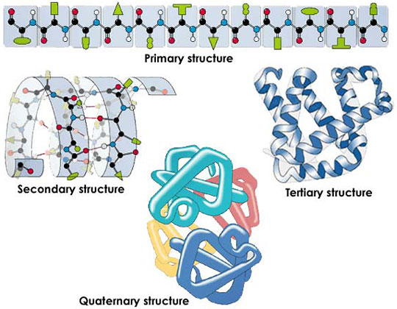
3. Glue them on your answer sheet in the appropriate place and answer the questions.
PROTEINS
Proteins are macromolecules that contain nitrogen as well as carbon, hydrogen, and oxygen. Proteins are polymers of molecules called amino acids. There are 20 different amino acids. Proteins are formed by joining amino acids together with peptide bonds (a special type of covalent bond). Proteins must fold in a specific way into a 3-D structure. A protein will not function properly if not folded into the correct shape.
Because proteins can form many unique shapes, there are thousands of different proteins with very different jobs: transport proteins move around specific molecules, antibodies defend the body against viruses and bacteria, enzymes regulate chemical reactions in the cell, hormones carry messages around the body, and muscle fibers interact to cause movement. These are just a few of the many jobs that proteins do in the cell.
Protein procedure:
1. Color the amino acids – each one a different color or pattern. There can be some repeats just as there are repeats of some amino acids in a protein.
2. DO NOT cut them apart, but tape the two strips together in one long chain. Fold and twist the chain into a 3-D shape similar to what you see labeled as tertiary structure (third level, pronounced TUR-shee-er-ee) in the picture above.
3. Glue only the ends of the chain and one amino acid in the middle to your answer sheet so that the 3-D shape is still intact in your model of the protein and answer the questions.
Name: __________________________________________ Date: __________ Period: ____
Macromolecules Cut & Paste Page
Carbohydrates
Monosaccharide | Disaccharide | Polysaccharide
- What is the monomer of a carbohydrate called? ___________________________________________
- Write the examples of mono-, di-, and poly- saccharide next to where you pasted the cut-outs above.
- What is the main function of carbohydrates? _______________________________________________
____________________________________________________________________________________

Lipids
- What are the monomers of lipids? __________________________ & ____________________________
- Label the lipid with all straight fatty acids SATURATED. Write examples of saturated fat next to it.
- Label the lipid with 1 kinked fatty acid UNSATURATED. Write the example of unsaturated fat next to it.
- What are three functions of lipids? ____________+__________________________________________
____________________________________________________________________________________
Nucleic Acids
DNA | RNA
- What is the monomer of all nucleic acids? __________________________________________________
- What is the main function of nucleic acids? _________________________________________________
- What do you notice about the nucleotides that fit together? ____________________________________ _____________________________________________________________________________________

Proteins
- What is the monomer of all proteins? ______________________________________________________
- How many different amino acids are there? _________ How many are found in the protein chain above? ________
- List at least 4 different types of proteins and their functions: ___________________________________
_____________________________________________________________________________________
- What is so different about proteins from the other macromolecules? _____________________________
_____________________________________________________________________________________

