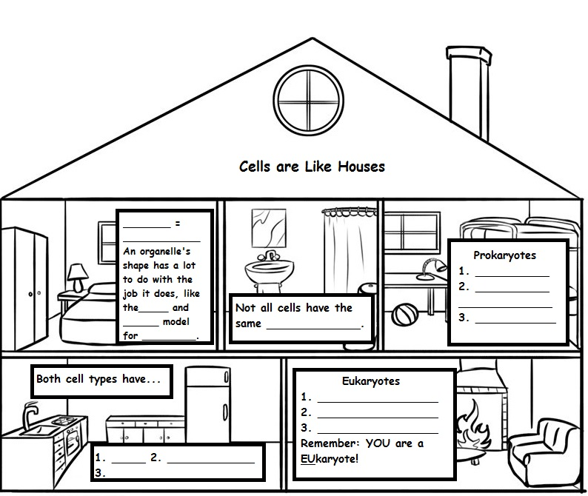
Organelles

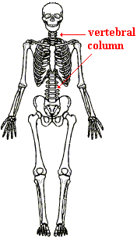  The cytoskeleton works like our skeleton. |  | ORGANELLES INVOLVED IN CELL SUPPORT |  |  |  | Contains the ___________in eukaryotic cells  Composed mostly of __________.  Many chemical reactions occur in the cytoplasm where water acts as a  ____________.
The cytoskeleton helps the cell maintain its ________and moves ____________around.  ALS, or Lou Gehrig’s disease occurs when there are ____________  cytoskeleton in the nerve cells. |  | Eukaryotic cells have a____________________, a framework of _____________that is constantly changing to meet the needs of the cell.  CYTO- MEANS  “CELL”
 |  |  |  | _________________ is a jelly-like substance that also helps the cell ____________ ____________________.
 | ORGANELLES INVOLVED IN THE CREATION OF PROTEINS
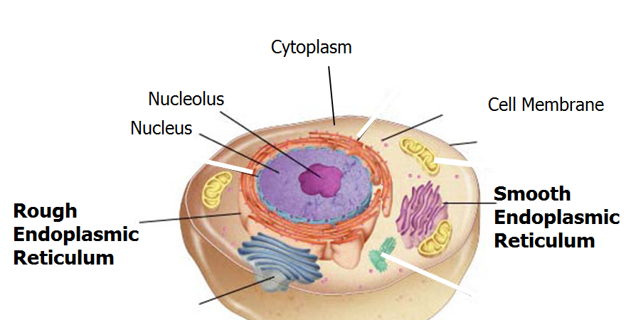
____________  The largest organelle in a ________________  cell. |  | ____________ link ________ ___________ together to make __________. |  | ________________ _______________ (ER)  is a _____________________  of thin, folded  _______________________. |  |  |  | ______________ ______________ function is to ___________, ___________, and ___________ proteins received from the ER  for ___________or  _________________  out of the cell.
Contains the cell’s ________________  information  (__________) |  | Some ribosomes are ____________  to the ER. |  | Creases and folds allow the ER to ______  ________________into the cell.  There are 2 kinds of ER: |  |  |  | Closely layered stacks of ______________  __________________.  PROTEIN PRODUCTION IN THE CELL  1. Ribosomes are made in the NUCLEOLUS.  2. Ribosomes leave the nucleolus via the nuclear pores  3. Amino acids are assembled by RIBOSOMES.  4. Protein assembly is completed in the ROUGH ENDOPLASMIC RETICULUM.  5. Proteins are carried in vesicles to the GOLGI to be modified or transported throughout the cell.
Surrounded by the  ________________  ________________  (also called nuclear membrane) |  | Some ribosomes are suspended in the ____________. |  | Rough ER  Rough ER is where proteins are_____________, ____________and ___________within the cell.  Rough ER is studded with ______________. |  | Smooth ER  Smooth ER does not have _____________.  It is the site where ____________ are made.
The nuclear envelope is pierced with holes called ________________ ________that allow ________________  ______________ to pass in and out of the nucleus. |  | Ribosomes are crucial for the synthesis of PROTEINS
The nucleus contains the ______________- a ________________ __________ where organelles called ______________are made. |  |  |  | Proteins are made on __________and inserted into Rough ER to be __________and  ______________to another organelle.

A LOOK AT THE ORGANELLES WE HAVE DISCUSSED
SO FAR-THEY ARE ALL INVOLVED IN MAKING PROTEINS.
OTHER ORGANELLES
The ________________ are bean-shaped organelles that supply ___________ to the cell  Surrounded by a ____________  _____________________.  Folded inner membrane _______________________  ____________ ___________  for more chemical  Reactions.  It is within these inner folds that chemical reactions occur that converts _________ __________into __________ _______________________.  The folds inside the mitochondria are called _______________________.  Nickname is the  __________________________  _____ _______ __________  The chemical reaction is called  ______________________  _______________________.  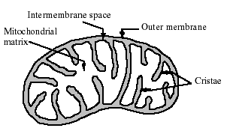 |  | ______________are small membrane-bound sacs that keep ______________from various chemical reactions separated from the rest of the cell.  They also __________these materials from place to place within the cell.  Vesicles are _________________  and are formed and __________________  by the cell as needed.  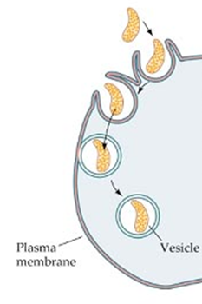 |  | A ___________is a ________________ ________________ ________used for the __________ of materials needed by the cell.  The vacuole stores materials such as  - _________  - Food molecules  - Ions  - _________ |  | ______________ are membrane bound sacs  that contain __________________  called _____________  _______________.
Lysosomes defend a cell from invading ______________.

They break down _________________
or worn-out cell parts.

Contain digestive enzymes.

 |  |  |  | LOOK FOR CENTRAL VACUOLE IN PLANT  CELLS |  | Programmed cell death is called __________________.  Lysosomes  ________________  unwanted cells
 | 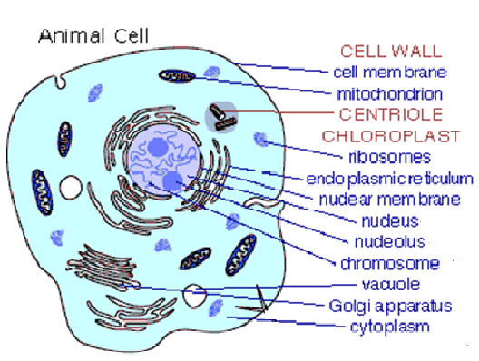 |  |  |  |  | People with Tay Sach’s disease lack a _________dissolving enzyme in their vesicles.  Causes lipids to accumulate in the______________.

